**Ready Now - First Floor Apartment 7 Charles King Court, Shifnal TF11 8AQ - 50% share £67,500.00**

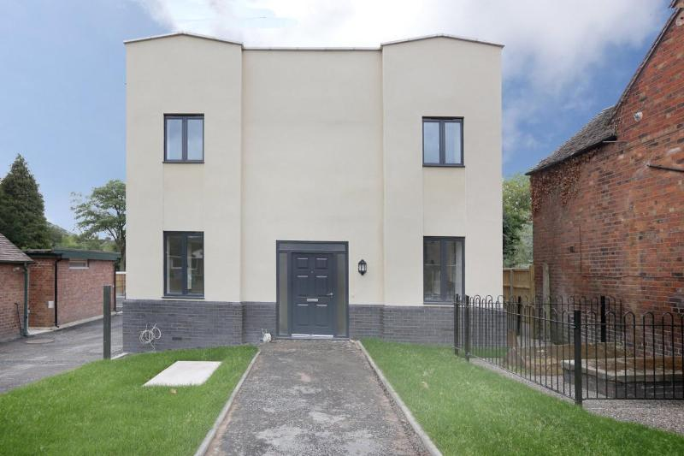

[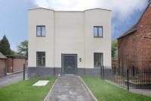](https://www.helptobuymidlands.co.uk/media/images/versions/img94joktmu754848.jpg)[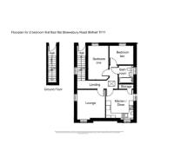](https://www.helptobuymidlands.co.uk/media/images/versions/img94joktmu754851.jpg)[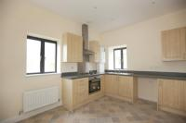](https://www.helptobuymidlands.co.uk/media/images/versions/img94joktmu754852.jpg)

[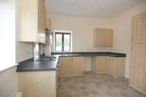](https://www.helptobuymidlands.co.uk/media/images/versions/img94joktmu754853.jpg) [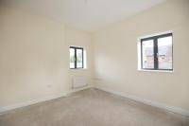](https://www.helptobuymidlands.co.uk/media/images/versions/img94joktmu754854.jpg) [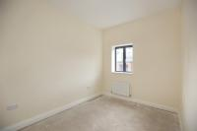](https://www.helptobuymidlands.co.uk/media/images/versions/img94joktmu754855.jpg)

[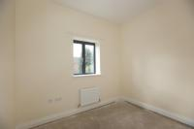](https://www.helptobuymidlands.co.uk/media/images/versions/img94joktmu754856.jpg) [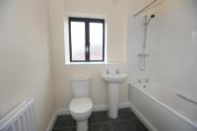](https://www.helptobuymidlands.co.uk/media/images/versions/img94joktmu754857.jpg)

A new development in the heart of Shifnal - Ready Now. Available for Shared Ownership for locals who live or work in Shifnal.

2 Bedroom Apartment

7 Charles King Court, Shifnal, Shropshire TF11 8GQ

Contact Name: **Your Move Perton**

Contact Phone: **01902 744111**

Contact Email: [**perton@your-move.co.uk**](mailto:perton@your-move.co.uk)

Contact Organisation: **Shropshire Towns & Rural Housing**

Contact Phone: **01743 210212**

Contact Email: [housing.development@starhousing.org.uk](mailto:housing.development@starhousing.org.uk)

Price: **£135,000**

A small development of 1 and 2 bedroomed apartments for rent and shared ownership in the heart of Shifnal being developed on behalf of Shropshire Council by Shropshire Towns and Rural Housing. The builders are Harpers of Leominster and all apartments have a NHBC 10 year guarantee. The apartments are on the site of the former Baptist Chapel, close to local shops, doctors’ surgery and mainline railway station. All potential purchaser must be registered with Shropshire Homepoint and have a strong local connection to Shifnal (either you currently live or work in Shifnal)

To include:

* Specifically developed for people living or working in Shifnal
* Shared ownership capped at 80%
* Own separate entrance to the rear of the building
* Fitted kitchen with gas hob and electric oven
* Bathroom with overbath shower
* Lounge
* Bedroom x2
* Communal garden
* Dedicated parking space
* Rent £38.67 per week
* Service charge to be confirmed
* EPC
* Gas central heating with combi boiler