Ready to Move Into Now - 9 Shrewsbury Road, Shifnal TF 11 8AQ

50% share £83,750.00
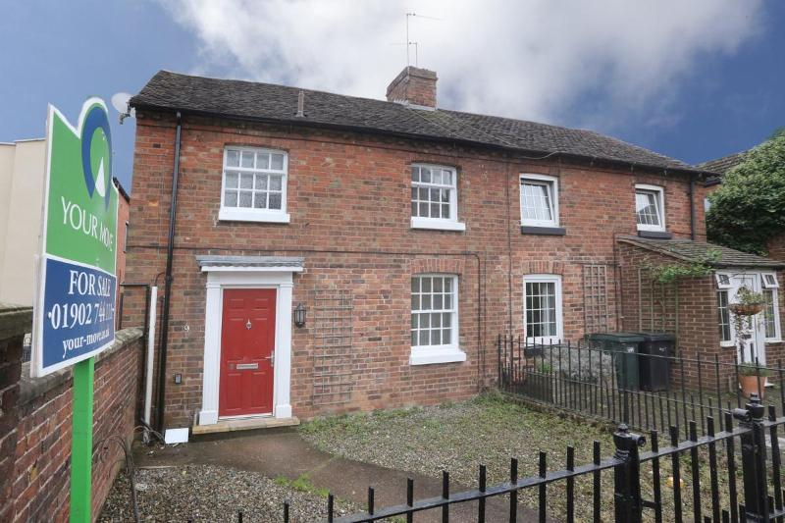
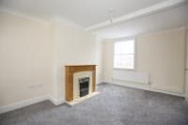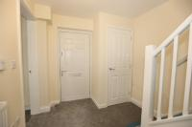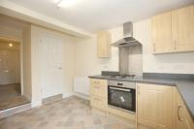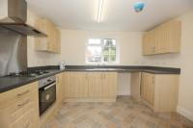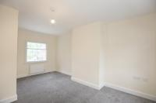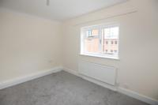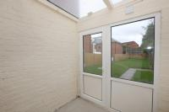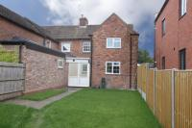

Part of a new development at Charles King Court Shifnal. A newly renovated 2 bedroomed semi-detached cottage.
9 Shrewsbury Road , Shifnal, Shropshire TF11 8AQ
Contact Name: YOUR MOVE PERTON
Contact Phone: 01902 7444111
Contact Email: Perton@your-move.co.uk
or
Contact Organisation: Shropshire Towns & Rural Housing

Contact Phone: 01743 210212

Contact email: housing.development@starhousing.org.uk
Price: £167,500
A small development of 1 and 2 bedroomed apartments for rent and shared ownership in the heart of Shifnal being developed on behalf of Shropshire Council by Shropshire Towns and Rural Housing. The builders are Harpers of Leominster. This well presented 2 bedroomed semi-detached cottage c1900 is in the heart of Shifnal and very close to local shops, doctors’ surgery, excellent local schools and mainline railway station. All potential purchaser must be registered with Help to Buy West Midlands & Shropshire Homepoint and have a strong local connection to Shifnal (either you currently live or work in Shifnal).Shares are capped at 80%. This well presented 2 bedroomed semi-detached cottage c1900 is in the heart of Shifnal. Available under Shared Ownership of 50% Available to interested parties who either live or work in Shifnal.
The property comprises of:
- Living Room
- Kitchen / dining room with gas hob and electric oven unit with cooker hood, led lighting and gas combi boiler.
- Bathroom with over bath shower handbasin & wc.
- 2 large bedrooms
- Large rear garden
- EPC rating TBC.
- Rent £47.98 per week over 48 weeks
- service charge TBC .
- allocated parking space
- Price is based on a 50% share
- Properties initially available to interested parties who live or work or have strong family connections in Shifnal

