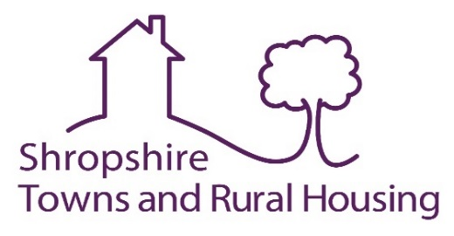

Anti-Money Laundering Declaration
This declaration form must be completed for each application to purchase, in all cases

Please return this completed form with your Right to Buy Application (RTB1) to:
Shropshire Towns and Rural Housing
Mount McKinley House
Anchorage Avenue
Shrewsbury Business Park
SY2 6FG

 | Tenant 1 | Tenant 2
First names
Surname
Date of birth

Address

Postcode

Please confirm below the names and addresses of all the people involved in the purchase (excluding yourself). This should include people who may be providing money who have not been named on the Right to Buy application.
Name | Address |  |  | Relationship to you
 |  | Postcode
 |  | Postcode
 |  | Postcode

You will need to provide documentation to confirm the identity of those listed above. (There is a list of acceptable documentation at the end of this form).
Please tell us where the money for the purchase is coming from. If family/friends are lending or gifting the money include their names below and where they will be obtaining the money from.
Name (You or family/friend) | Source  (i.e. mortgage, savings, loan, inheritance) | Amount (% of purchase) *

*Please note, if you are getting a mortgage the Amount/percentage will be 100%.

All the people involved in the purchase must read and sign this.
• I / we declare that the information I / we have given on this form is correct and complete.
• I / we understand that if incorrect or incomplete information is knowingly given, I / we may be liable to prosecution or other appropriate action.
• I / we understand that the verification process of my RTB application will include ST&RH undertaking a credit check with a credit referencing agency, of which I agree to.
• I / we understand the information provided will be used for money laundering purposes. It may also be shared with other council services and data processors acting on behalf of the council, in order to prevent and detect fraud and protect public funds.

Name (Print) |  |  |  |  |  |  | Signature  Signature  Signature  Signature
Date
 | D | D | M | M | Y | Y

Name (Print) |  |  |  |  |  |  | Signature Signature  Signature  Signature  Signature
Date
 | D | D | M | M | Y | Y

Name (Print) |  |  |  |  |  |  | Signature  Signature  Signature  Signature
Date
 | D | D | M | M | Y | Y

Name (Print) |  |  |  |  |  |  | Signature  Signature  Signature  Signature
Date
 | D | D | M | M | Y | Y

For each person included on this form you are required to confirm their identity. Documentation must be either a driver’s license, passport, birth certificate or Home Office documentation (where applicable). Only original documents will be accepted

